1. Merging data in SAS :

Merging datasets is the most important step for an analyst. Merging data can be done through both DATA step and PROC SQL. Usually people ignore the difference in the method used by SAS in the two different steps. This is because generally there is no difference in the output created by the two routines. Lets look at the following example :

[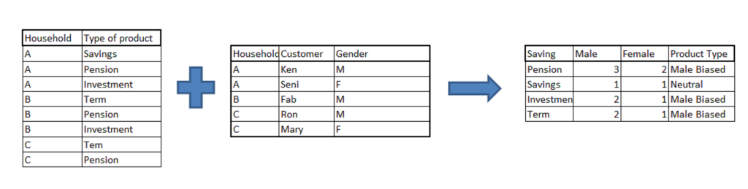](http://www.analyticsvidhya.com/blog/wp-content/uploads/2013/11/Merge1.png)

Problem Statement : In this example, we have 2 datasets. First table gives the product holding for a particular household. Second table gives the gender of each customer in these households. What you need to find out is that if the product is Male biased or neutral. The Male biased product is a product bought by males more than females. You can assume that the product bought by a household belongs to each customer of that household.

Thought process: The first step of this problem is to merge the two tables. We need a Cartesian product of the two tables in this case. After getting the merged dataset, all you need to do is summarize the merged dataset and find the bias.

Code 1

Proc sort data = PROD out =A1; by household;run;

Proc sort data = GENDER out =A2; by household;run;

Data MERGED;

merge A1(in=a) A2(in=b);

by household;

if a AND b;

run;

Code 2 :

PROC SQL;

Create table work.merged as

select t1.household,  t1.type,t2.gender

from prod as t1, gender as t2

where t1.household = t2.household;

quit;

Will both the codes give the same result?

The answer is NO. As you might have noticed, the two tables have many-to-many mapping. For getting a cartesian product, we can only use PROC SQL. Apart from many-to-many tables, all the results of merging using the two steps will be exactly same.

Why do we use DATA – MERGE step at all?

DATA-MERGE step is much faster compared to PROC SQL. For big data sets except one having many-to-many mapping, always use DATA- MERGE.

2. Transpose data-sets :

When working on transactions data, we frequently transpose datasets to analyze data. There are two kinds of transposition. First, transposing from wide structure to narrow structure. Consider the following example :

[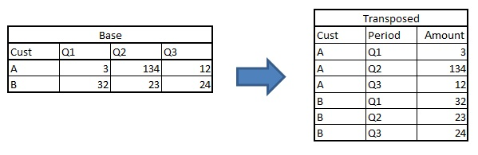](http://www.analyticsvidhya.com/blog/wp-content/uploads/2013/11/transpose-1.jpg)

Following are the two methods to do this kind of transposition :

a. DATA STEP :

data transposed;set base;

array Qtr{3} Q:;

do i = 1 to 3;Period = cat('Qtr',i);Amount = Qtr{i} ;output;end;

drop Q1:Q3;

if Amount ne .;

run;

b. PROC TRANSPOSE :

proc transpose data = base out = transposed

(rename=(Col1=Amount) where=(Amount ne .)) name=Period;

by cust; run;

In this kind of transposition, both the methods are equally good. PROC TRANSPOSE however takes lesser time because it uses indexing to transpose.

Second, narrow to wide structure. Consider an opposite of the last example.

[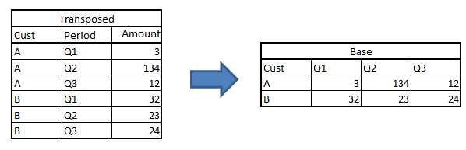](http://www.analyticsvidhya.com/blog/wp-content/uploads/2013/11/transpose-21.png)

For this kind of transposition, data step becomes very long and time consuming. Following is a much shorter way to do the same task,

Proc transpose data=transposed out=base (drop=\_name\_) prefix Q;

by cust;

id period;

var amount;

run;

3. Passing values from one routine to other:

Imagine a scenario, we want to compare the total marks scored by two classes. Finally the output should be simply the name of the class with the higher score. The score of the two datasets is stored in two separate tables.

There are two methods of doing this question. First, append the two tables and sum the total marks for each or the classes. But imagine if the number of students were too large, we will just multiply the operation time by appending the two tables. Hence, we need a method to pass the value from one table to another. Try the following code:

[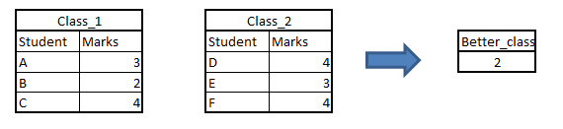](http://www.analyticsvidhya.com/blog/wp-content/uploads/2013/11/Pass.png)

DATA \_null\_;set class\_1;

total + marks;

call symputx ('class1\_tot',total);

run;

DATA \_null\_;set class\_2;

total + marks;

call symputx ('class2\_tot',total);

run;

DATA results;

if &class1\_tot > &class2\_tot then better\_class = 1;

else if &class1\_tot > &class2\_tot then better\_class = 2;

else better\_class = 0;

run;

Funtion symputx creates a macro variable which can be passed between various routines and thus gives us an opportunity to link data-sets.

4. Using where and if :

“Where” and “if” are both used for sub-setting. Most of the times where and if can be used interchangeably in data step for sub-setting. But, when sub-setting is done on a newly created variable, only if statement can be used. For instance, consider the following two programs,

Code 1 :                                                                                  Code 2 :

data a;set b;                         data a;set b;

z= x+y;                                  z= x+y;

if z < 10;                               where z < 10;

run;                                     run;

Code 2 will give an error in this case, because where cannot be used for sub-setting data based on a newly created variable.

End Notes :

These codes come directly from my cheat chit. What is especial about these 4 codes, that in aggregate they give me a quick glance to almost all the statement and options used in SAS. If you were able to solve all the questions covered in this article, we think you are up for the next level. You can read the second part of this article here ( http://www.analyticsvidhya.com/blog/2014/04/tricky-base-sas-interview-questions-part-ii/ ) . The second part of the article will have tougher and lengthier questions as compared to those covered in this article.

Have you faced any other SAS problem in analytics interview? Are you facing any specific problem with SAS codes?  Do you think this provides a solution to any problem you face? Do you think there are other methods to solve the problems discussed in a more optimized way? Do let us know your thoughts in the comments below.

You can read [part II of this article here](http://www.analyticsvidhya.com/blog/2014/04/tricky-base-sas-interview-questions-part-ii/)

If you like what you just read & want to continue your analytics learning, [subscribe to our emails](http://feedburner.google.com/fb/a/mailverify?uri=analyticsvidhya) or like our [facebook page](http://facebook.com/analyticsvidhya" \t "_blank).

Share this:

[Click to share on LinkedIn (Opens in new window)](http://www.analyticsvidhya.com/blog/2013/11/4-sas-tricky-analytics-interview/?share=linkedin)

[Share on Facebook (Opens in new window)](http://www.analyticsvidhya.com/blog/2013/11/4-sas-tricky-analytics-interview/?share=facebook)

[Click to share on Google+ (Opens in new window)](http://www.analyticsvidhya.com/blog/2013/11/4-sas-tricky-analytics-interview/?share=google-plus-1)

[Click to share on Twitter (Opens in new window)](http://www.analyticsvidhya.com/blog/2013/11/4-sas-tricky-analytics-interview/?share=twitter)

[Click to share on Pocket (Opens in new window)](http://www.analyticsvidhya.com/blog/2013/11/4-sas-tricky-analytics-interview/?share=pocket)

[Click to share on Reddit (Opens in new window)](http://www.analyticsvidhya.com/blog/2013/11/4-sas-tricky-analytics-interview/?share=reddit)

[Click to share on StumbleUpon (Opens in new window)](http://www.analyticsvidhya.com/blog/2013/11/4-sas-tricky-analytics-interview/?share=stumbleupon)

Related

[](http://www.analyticsvidhya.com/blog/2014/04/tricky-base-sas-interview-questions-part-ii/)

[Tricky Base SAS interview questions : Part-II](http://www.analyticsvidhya.com/blog/2014/04/tricky-base-sas-interview-questions-part-ii/)

SAS is the largest market-share holder for advanced analytics. If you are going to work in analytics industry, it is impossible to escape from the language SAS. Different softwares of SAS are used in the industry for data handling. Most common of them used in data handling are SAS Enterprise guide…

April 13, 2014

In "Analytics Vidhya"

[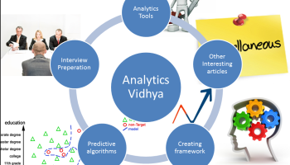](http://www.analyticsvidhya.com/blog/2014/12/start-career-analytics-industry/)

[All you need to know to start a career in analytics](http://www.analyticsvidhya.com/blog/2014/12/start-career-analytics-industry/)

In last two years, we have successfully tried creating a community dedicated to share best practices across industry and give a kick start to all newbies. We received unconditional support from the people in the industry beyond the boundaries of experience and geography. If you search analyticsvidhya.com for any relevant…

December 7, 2014

In "Business Analytics"

[](http://www.analyticsvidhya.com/blog/2014/05/tricky-interview-questions/)

[4 Tricky R interview questions](http://www.analyticsvidhya.com/blog/2014/05/tricky-interview-questions/)

Analytics industry in India is dominated by SAS currently. But, it will be too optimistic to hope that this remains to in years to come. R, on the other hand is open source, and can be implemented in any environment. SAS grows by efforts of smart people employed by SAS but  R…

May 14, 2014

In "Business Analytics"

Tags: [Analytics](http://www.analyticsvidhya.com/blog/tag/analytics/), [base SAS](http://www.analyticsvidhya.com/blog/tag/base-sas/), [Business Analytics](http://www.analyticsvidhya.com/blog/tag/business-analytics/), [interview](http://www.analyticsvidhya.com/blog/tag/interview/), [interview questions](http://www.analyticsvidhya.com/blog/tag/interview-questions/), [SAS](http://www.analyticsvidhya.com/blog/tag/sas/)

[Next Article](http://www.analyticsvidhya.com/blog/2013/11/interview-top-data-scientist-kaggler-mr-steve-donoho/)

[Interview with data scientist and top Kaggler, Mr. Steve Donoho](http://www.analyticsvidhya.com/blog/2013/11/interview-top-data-scientist-kaggler-mr-steve-donoho/)

[Previous Article](http://www.analyticsvidhya.com/blog/2013/11/view-release-tableau-8-1/)

[Review: Tableau 8.1](http://www.analyticsvidhya.com/blog/2013/11/view-release-tableau-8-1/)

[](http://www.analyticsvidhya.com/blog/author/tavish1/)

Author

[Tavish Srivastava](http://www.analyticsvidhya.com/blog/author/tavish1/)

I am Tavish Srivastava, a post graduate from IIT Madras in Mechanical Engineering. I have more than two years of work experience in Analytics. My experience ranges from hands on analytics in a developing country like India to convince banking partners with analytical solution in matured market like US. For last two and a half years I have contributed to various sales strategies, marketing strategies and Recruitment strategies in both Insurance and Banking industry.

Related Articles

http://2.gravatar.com/avatar/51bf7a2a1f2a0dd3a1012fa4cf5a9e80?s=48&d=mm&r=g[Tavish Srivastava](http://www.analyticsvidhya.com/blog/author/tavish1/), June 20, 2014

[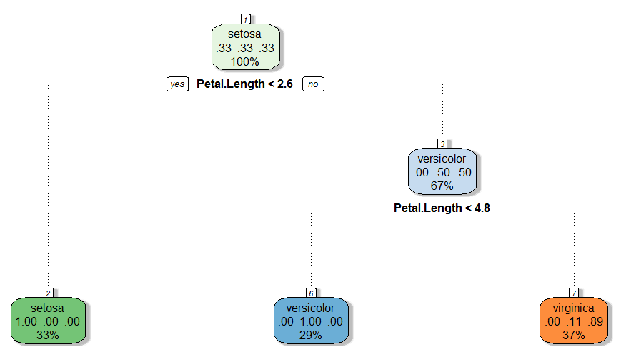](http://www.analyticsvidhya.com/blog/2014/06/comparing-cart-random-forest-1/)

[Comparing a CART model to Random Forest (Part 1)](http://www.analyticsvidhya.com/blog/2014/06/comparing-cart-random-forest-1/)

http://1.gravatar.com/avatar/4881b6eff4a916300c9a785c9f103f24?s=48&d=mm&r=g[Kunal Jain](http://www.analyticsvidhya.com/blog/author/kunalj/), March 26, 2015

[](http://www.analyticsvidhya.com/blog/2015/03/big-data-analytics-based-start-ups-combinator-winter-2015-batch/)

[Big Data / Analytics based startups at Y Combinator, Winter 2015 batch](http://www.analyticsvidhya.com/blog/2015/03/big-data-analytics-based-start-ups-combinator-winter-2015-batch/)

http://2.gravatar.com/avatar/51bf7a2a1f2a0dd3a1012fa4cf5a9e80?s=48&d=mm&r=g[Tavish Srivastava](http://www.analyticsvidhya.com/blog/author/tavish1/), October 3, 2014

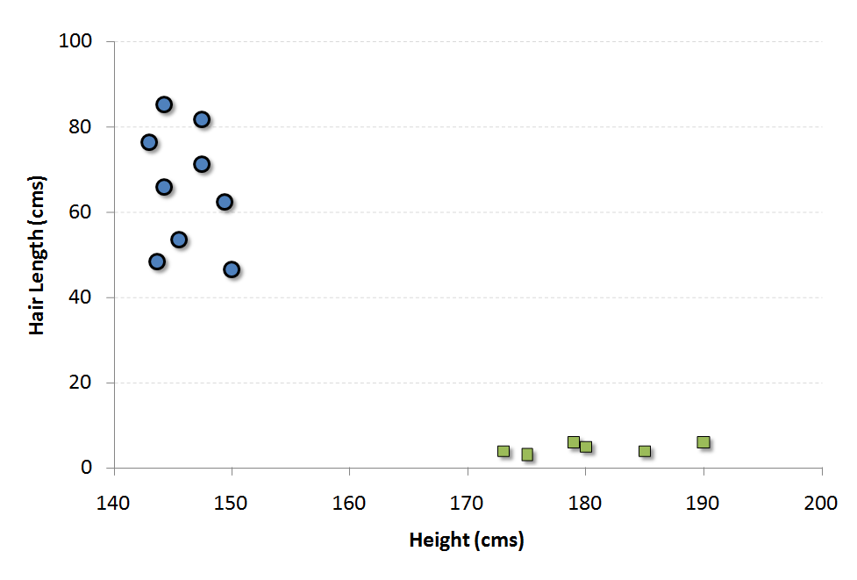

[Support Vector Machine – Simplified](http://www.analyticsvidhya.com/blog/2014/10/support-vector-machine-simplified/)

32 Comments

Priya Varshney says:

[November 27, 2013 at 3:49 pm](http://www.analyticsvidhya.com/blog/2013/11/4-sas-tricky-analytics-interview/#comment-2816)

1. Merging data in SAS :  
is complete answer is  
Data A;  
Input household $ type\_of\_product $13.;  
Datalines;  
A savings  
A pension  
A investment  
B term  
B pension  
B investment  
C term  
C pension  
;

run;  
proc print;  
run;  
Data B;  
input household $ Customer $ gender $;  
datalines;  
A Ken M  
A Seni F  
B Fab M  
C Ron M  
C Mary F  
;  
run;  
Proc sort data = a out =A1; by household;run;  
Proc sort data = b out =A2; by household;run;  
Data MERGED;  
merge A1(in=a) A2(in=b);  
by household;  
if a AND b;  
run;

proc print data=merged;  
run;  
PROC SQL;  
Create table work.merged as  
select t1.household, t1.type,t2.gender  
from a as t1, b as t2  
where t1.household = t2.household;  
quit;  
proc sort data=merged out=f;  
by type\_of\_product;  
run;

data final;  
retain f 0;  
retain m 0;  
set f;  
by type\_of\_product;  
if gender=”F” then f=f+1;  
if gender=”M” then m=m+1;  
if last.type\_of\_product then do;  
if f>m then product\_type=”Female based”;  
else  
if m>f then product\_type=”Male based”;  
else  
product\_type=”Neutral”;  
output;  
f=0;  
m=0;  
end;  
drop household customer gender f m ;  
run;

proc print data=final;  
run;

[Reply](http://www.analyticsvidhya.com/blog/2013/11/4-sas-tricky-analytics-interview/?replytocom=2816#respond)

Priya Varshney says:

[November 27, 2013 at 3:51 pm](http://www.analyticsvidhya.com/blog/2013/11/4-sas-tricky-analytics-interview/#comment-2817)

Question 1 answer  
Data A;  
Input household $ type\_of\_product $13.;  
Datalines;  
A savings  
A pension  
A investment  
B term  
B pension  
B investment  
C term  
C pension  
;

run;  
proc print;  
run;  
Data B;  
input household $ Customer $ gender $;  
datalines;  
A Ken M  
A Seni F  
B Fab M  
C Ron M  
C Mary F  
;  
run;  
Proc sort data = a out =A1; by household;run;  
Proc sort data = b out =A2; by household;run;  
Data MERGED;  
merge A1(in=a) A2(in=b);  
by household;  
if a AND b;  
run;

proc print data=merged;  
run;  
PROC SQL;  
Create table work.merged as  
select t1.household, t1.type,t2.gender  
from a as t1, b as t2  
where t1.household = t2.household;  
quit;  
proc sort data=merged out=f;  
by type\_of\_product;  
run;

data final;  
retain f 0;  
retain m 0;  
set f;  
by type\_of\_product;  
if gender=”F” then f=f+1;  
if gender=”M” then m=m+1;  
if last.type\_of\_product then do;  
if f>m then product\_type=”Female based”;  
else  
if m>f then product\_type=”Male based”;  
else  
product\_type=”Neutral”;  
output;  
f=0;  
m=0;  
end;  
drop household customer gender f m ;  
run;

proc print data=final;  
run;

[Reply](http://www.analyticsvidhya.com/blog/2013/11/4-sas-tricky-analytics-interview/?replytocom=2817#respond)

Anders Sköllermo says:

[January 1, 2014 at 2:52 pm](http://www.analyticsvidhya.com/blog/2013/11/4-sas-tricky-analytics-interview/#comment-4098)

Hi! COMMENT to the answer to “4. Using where and if : ”

Suppose SAS-table B (WORK.B) contains a variable B, then the solution in Code 2 will work:  
data a;set b; z= x+y; /\* The old value of Z, which was < 10, will be replaces. \*/ where z < 10; run;

The WHERE-clause should (in my opinion) immediately follow the SET-statement.  
Easy question! Easy answer!

Basic questions: What data do You have ? What rules do you have? What results do you want ?  
THEN we can start to discuss what is CORRECT and what is (perhaps) "a little less correct"  
(British English understatement).  
/ Br Anders

[Reply](http://www.analyticsvidhya.com/blog/2013/11/4-sas-tricky-analytics-interview/?replytocom=4098#respond)

sandy says:

[January 24, 2014 at 4:25 pm](http://www.analyticsvidhya.com/blog/2013/11/4-sas-tricky-analytics-interview/#comment-4265)

Reply to answer 4 .  
Simple diff b/w IF and WHERE CLAUSE.  
IF works on pdv, where as WHERE works on source and applies conditions so new cant be created in WHERE.  
so there In code2 shows error.

[Reply](http://www.analyticsvidhya.com/blog/2013/11/4-sas-tricky-analytics-interview/?replytocom=4265#respond)

Anders Sköllermo says:

[January 25, 2014 at 5:26 pm](http://www.analyticsvidhya.com/blog/2013/11/4-sas-tricky-analytics-interview/#comment-4274)

Hi! Type error. My note should read: “Suppose SAS-table B (WORK.B) contains a variable Z, …”  
(The drawback of writing the answers late at night..).

In other words: If you have a variable Z and also create a variable Z, then the result depends strongly  
on the use of WERE (the old Z value) or IF (the newly calculated Z value).

The programmers show give some thoughts to data structures, what variables are created where, what results are wanted.  
/ Br Anders

[Reply](http://www.analyticsvidhya.com/blog/2013/11/4-sas-tricky-analytics-interview/?replytocom=4274#respond)

Anders Sköllermo says:

[January 25, 2014 at 5:30 pm](http://www.analyticsvidhya.com/blog/2013/11/4-sas-tricky-analytics-interview/#comment-4275)

Case 4: Bottom Line: Case 2 with WHERE may work “fine”, without any errors at all.

[Reply](http://www.analyticsvidhya.com/blog/2013/11/4-sas-tricky-analytics-interview/?replytocom=4275#respond)

Tavish says:

[January 26, 2014 at 12:38 pm](http://www.analyticsvidhya.com/blog/2013/11/4-sas-tricky-analytics-interview/#comment-4288)

Anders,  
Thanks for bringing this up. You are right in saying that in case “z” is already a variable of the set data-set, the code won’t show error. But the objective of bringing this up was that , as sandy quoted, “IF works on pdv, where as WHERE works on source and applies conditions” . But that was a sharp catch for sure.

Tavish

[Reply](http://www.analyticsvidhya.com/blog/2013/11/4-sas-tricky-analytics-interview/?replytocom=4288#respond)

bhanu says:

[January 28, 2014 at 8:30 am](http://www.analyticsvidhya.com/blog/2013/11/4-sas-tricky-analytics-interview/#comment-4318)

Hi Tavish,

I do know about base sas and macros but i want to know more about banking projects how it goes on the daily basis.I want to know about the work of the analyst in a banking domain from the scratch.Can u please help me in guiding me as u r also from the same domain.I really appreciate your efforts u r investing for the young professionals.

Thanks in Anticipation  
Bhanu

[Reply](http://www.analyticsvidhya.com/blog/2013/11/4-sas-tricky-analytics-interview/?replytocom=4318#respond)

Shivi says:

[February 10, 2014 at 10:27 am](http://www.analyticsvidhya.com/blog/2013/11/4-sas-tricky-analytics-interview/#comment-4430)

Following on email

[Reply](http://www.analyticsvidhya.com/blog/2013/11/4-sas-tricky-analytics-interview/?replytocom=4430#respond)

Anders Sköllermo says:

[February 10, 2014 at 5:26 pm](http://www.analyticsvidhya.com/blog/2013/11/4-sas-tricky-analytics-interview/#comment-4434)

Hi! The real meaning of the WHERE-statement:  
The WHERE statement is (approximately) a WHERE data set option:  
data a;  
set b (where=(z < 10));  
Z= x+y;  
run;

The WHERE statement cannot be executed conditionally. That is, you cannot use it as part of an IF-THEN statement. (according to SAS9.3 manuals).

data a;  
set b;  
where=z < 10;  
Z= x+y;  
run;

Please note that the following is OK (but I would NEVER write like that)  
data a;  
where=z < 10; /\* WHERE on SET WORK.B – not on WORK.A ! \*/  
set b;  
Z= x+y;  
run;

The following is OK and works as it should – BUT DO NOT USE IT !!  
data work.a;  
if x=1 then do;  
where=z < 10;  
end; /\* The WHERE-part is a declaration and will always be used! \*/  
set work.b;  
z= x+y;  
run;

My way of writing SAS programs: Learn the actual syntax and functionality of all the parts that you use.  
Write very clear SAS-programs with a lot of documentation.

[Reply](http://www.analyticsvidhya.com/blog/2013/11/4-sas-tricky-analytics-interview/?replytocom=4434#respond)

Anders Sköllermo says:

[February 10, 2014 at 9:53 pm](http://www.analyticsvidhya.com/blog/2013/11/4-sas-tricky-analytics-interview/#comment-4436)

Use WHERE-data set option and IF statement together!

It can be handy to use the WHERE data set option (perhaps written as the WHERE statement) to restrict what observation are used in the data step AND one or several IF statements do do further calculations and selections on these observations, using the newly calculated variables.

[Reply](http://www.analyticsvidhya.com/blog/2013/11/4-sas-tricky-analytics-interview/?replytocom=4436#respond)

DaveG says:

[March 2, 2014 at 12:22 pm](http://www.analyticsvidhya.com/blog/2013/11/4-sas-tricky-analytics-interview/#comment-4596)

hi,

good set of four questions.

the proc transpose vs the data step: These programs do the same thing but they are \*not\* equivalent or equally useful.  
Why?

The data step as programmed has to have 3 occurences per set, exactly three.  
The Proc transpose works for any number of occurences (and creates any number of variables when ging from thin to wide).

In practical use this is important and I would not accept the assertion these methods are the same if I heard that in an interview.

[Reply](http://www.analyticsvidhya.com/blog/2013/11/4-sas-tricky-analytics-interview/?replytocom=4596#respond)

Tavish Srivastava says:

[March 2, 2014 at 1:06 pm](http://www.analyticsvidhya.com/blog/2013/11/4-sas-tricky-analytics-interview/#comment-4598)

Dave,  
You made a really good point here. As is, data step and proc transpose do the same job strictly for the data set mentioned in the article. However, if the number of variable increase you need to change the array length.

But, in case you want to make the array length variable, it is indeed possible. Here is how it can be done,  
1.Replace 3 by “\*” in array definition.  
2. Make a variable which will take the length of the array.  
3. Use the defined variable in the Do loop.

Do let me know in case you still disagree.

Tavish

[Reply](http://www.analyticsvidhya.com/blog/2013/11/4-sas-tricky-analytics-interview/?replytocom=4598#respond)

DaveG says:

[March 2, 2014 at 12:24 pm](http://www.analyticsvidhya.com/blog/2013/11/4-sas-tricky-analytics-interview/#comment-4597)

BTW it is easy to do example 3 with one datastep and no macro variables. 

[Reply](http://www.analyticsvidhya.com/blog/2013/11/4-sas-tricky-analytics-interview/?replytocom=4597#respond)

Tavish Srivastava says:

[March 2, 2014 at 1:08 pm](http://www.analyticsvidhya.com/blog/2013/11/4-sas-tricky-analytics-interview/#comment-4599)

Dave,  
It will be great for us and our viewers if you illustrate how it can be done in one data-step. I have no doubts that you know such a method 

Tavish

[Reply](http://www.analyticsvidhya.com/blog/2013/11/4-sas-tricky-analytics-interview/?replytocom=4599#respond)

[Tricky Base SAS interview questions : Part-II](http://www.analyticsvidhya.com/blog/2014/04/tricky-base-sas-interview-questions-part-ii/) says:

[April 13, 2014 at 11:22 am](http://www.analyticsvidhya.com/blog/2013/11/4-sas-tricky-analytics-interview/#comment-5430)

[…] of our previous articles (<http://www.analyticsvidhya.com/blog/2013/11/4-sas-tricky-analytics-interview/>) covers four tricky questions asked in SAS interviews. In this article, I will cover some tricky […]

[Reply](http://www.analyticsvidhya.com/blog/2013/11/4-sas-tricky-analytics-interview/?replytocom=5430#respond)

priya says:

[May 12, 2014 at 10:01 am](http://www.analyticsvidhya.com/blog/2013/11/4-sas-tricky-analytics-interview/#comment-7622)

alternative solution for case1 using proc sql:

data one;  
infile datalines;  
input household $ product\_type $10.;  
datalines;  
A Savings  
A Pension  
A Investment  
B Term  
B Pension  
B Investment  
C Term  
C Pension  
;

data two;  
infile datalines;  
input household $ Customer $ Gender $;  
datalines;  
A Ken M  
A Seni F  
B Fab M  
B Ron M  
C Mary F  
;

proc sort data=one;  
by household;  
run;  
proc sort data=two;  
by household;  
run;

PROC SQL;

Create table work.merged as  
select t1.household, t1.product\_type,t2.gender  
from one as t1, two as t2  
where t1.household = t2.household;

create table male(drop=gender)  
as select distinct product\_type as saving,gender,count(gender) as Male  
from merged  
group by saving,gender  
having gender=’M';

create table female(drop=gender)  
as select distinct product\_type as saving,gender,count(gender) as female  
from merged  
group by saving,gender  
having gender=’F';

create table joined as select m.saving,male,female,  
case  
when male>female then ‘Male-based’  
when female>male then ‘Female-based’  
else ‘Neutral’  
end as biased  
from male m,female f  
where m.saving=f.saving  
order by saving;  
quit;

[Reply](http://www.analyticsvidhya.com/blog/2013/11/4-sas-tricky-analytics-interview/?replytocom=7622#respond)

[4 Tricky R interview questions](http://www.analyticsvidhya.com/blog/2014/05/tricky-interview-questions/) says:

[May 14, 2014 at 12:52 pm](http://www.analyticsvidhya.com/blog/2013/11/4-sas-tricky-analytics-interview/#comment-7904)

[…] will give a kick-start to such a thread.  We have a similar series of articles published on SAS (Part 1 and Part 2). Please note that the content of this article is based on the information I gathered […]

[Reply](http://www.analyticsvidhya.com/blog/2013/11/4-sas-tricky-analytics-interview/?replytocom=7904#respond)

Aparna Konda says:

[May 27, 2014 at 6:20 am](http://www.analyticsvidhya.com/blog/2013/11/4-sas-tricky-analytics-interview/#comment-9226)

What is the major difference between Datalines and Cards in SAS programming?

[Reply](http://www.analyticsvidhya.com/blog/2013/11/4-sas-tricky-analytics-interview/?replytocom=9226#respond)

Shreesh says:

[June 6, 2014 at 5:50 pm](http://www.analyticsvidhya.com/blog/2013/11/4-sas-tricky-analytics-interview/#comment-9964)

Before datalines come in sas cards are used, its a version up-gradation.  
it is also note hat cards works on infile also.

[Reply](http://www.analyticsvidhya.com/blog/2013/11/4-sas-tricky-analytics-interview/?replytocom=9964#respond)

[Kunal Jain](http://www.analyticsvidhya.com) says:

[June 9, 2014 at 11:02 pm](http://www.analyticsvidhya.com/blog/2013/11/4-sas-tricky-analytics-interview/#comment-10214)

Thanks Shreesh

[Reply](http://www.analyticsvidhya.com/blog/2013/11/4-sas-tricky-analytics-interview/?replytocom=10214#respond)

Anu says:

[July 1, 2014 at 12:22 am](http://www.analyticsvidhya.com/blog/2013/11/4-sas-tricky-analytics-interview/#comment-12894)

In short: No difference.

In detail: Before the invention of terminals/keyboards, programs (software) and data all were prepared in cards with special punching machines that make holes in the cards to represent numbers and characters. In those years SAS developers used the statement cards to refer data, indirectly meaning “beyond this card, data are provided”. In fact they should have used the term “datacards” instead of cards.

Most of the programs are written once but used repeatedly. Data are varying for each use. So we prepare the programs, of course, in cards. After verifying it works correct we record the program in Tapes or disks permanently. Second time on wards we call the program from tape or disks and supply the data via cards. To each job, there will a few cards at the beginning of the card stack that will have job control lines giving information about the storage location and name of the program. Then data follow after a card that carries the message “cards”.

Other than this reason, there is absolutely no difference between cards and datalines.

[Reply](http://www.analyticsvidhya.com/blog/2013/11/4-sas-tricky-analytics-interview/?replytocom=12894#respond)

Anders says:

[June 7, 2014 at 7:03 pm](http://www.analyticsvidhya.com/blog/2013/11/4-sas-tricky-analytics-interview/#comment-10029)

Comment about CARDS; and DATALINES;  
In 1976 when SAS was (officially) released, data were read from records 80 bytes broad.  
Often the data were included, so you first had the Data step, which ended with CARDS; statement. After that came the data rows. The end of the data cards / data rows was signalled using RUN;

DATALINES means exactly the same as CARDS (as far as I know).

Often it is better to store the data in a separate file, which you refer to using the INFILE statement. Then specify how to read the data using the INPUT statement. CARDS or DATLINES is not used.  
/ BAr Anders

[Reply](http://www.analyticsvidhya.com/blog/2013/11/4-sas-tricky-analytics-interview/?replytocom=10029#respond)

[Kunal Jain](http://www.analyticsvidhya.com) says:

[June 9, 2014 at 9:00 pm](http://www.analyticsvidhya.com/blog/2013/11/4-sas-tricky-analytics-interview/#comment-10202)

Thanks Anders for answering the question.

Regards,  
Kunal

[Reply](http://www.analyticsvidhya.com/blog/2013/11/4-sas-tricky-analytics-interview/?replytocom=10202#respond)

Anders says:

[June 9, 2014 at 9:52 pm](http://www.analyticsvidhya.com/blog/2013/11/4-sas-tricky-analytics-interview/#comment-10211)

Hi! A reply to myself.  
Please note that INFILE CARDS; is the default. This means that after the Cards; or Datalines; statement, there will be datalines. (CARDS on the INFILE statement is an option for INFILE).  
/ Br Anders

[Reply](http://www.analyticsvidhya.com/blog/2013/11/4-sas-tricky-analytics-interview/?replytocom=10211#respond)

[The definitive guide to prepare for analytics interview](http://www.analyticsvidhya.com/blog/2014/07/definitive-guide-prepare-analytics-interview/) says:

[July 8, 2014 at 3:40 am](http://www.analyticsvidhya.com/blog/2013/11/4-sas-tricky-analytics-interview/#comment-13593)

[…] Tricky questions on SAS – part I and part II […]

[Reply](http://www.analyticsvidhya.com/blog/2013/11/4-sas-tricky-analytics-interview/?replytocom=13593#respond)

[Quick test to judge your level in analytics](http://www.analyticsvidhya.com/blog/2014/09/test-level-expertise-sasrpython/) says:

[September 10, 2014 at 10:02 pm](http://www.analyticsvidhya.com/blog/2013/11/4-sas-tricky-analytics-interview/#comment-22179)

[…] Currently R, SAS and Python are the three languages ruling the analytics industry. Expertise in at least one of the three language is a must to build a competitive profile. But mastering only one language might not make you a hot selling property. Even if you are not an expert in each of the three languages, you need to know what is the arena of strength for the three languages. In some of our previous articles, we covered interview questions in R (here) and SAS ( here). […]

[Reply](http://www.analyticsvidhya.com/blog/2013/11/4-sas-tricky-analytics-interview/?replytocom=22179#respond)

Amanpreet says:

[November 7, 2014 at 12:57 pm](http://www.analyticsvidhya.com/blog/2013/11/4-sas-tricky-analytics-interview/#comment-39329)

Hi Kunal,

Nice questions above.  
Similarly can u share an example for nodup and nodupkey.

This is confusing me.

Thanks aman

[Reply](http://www.analyticsvidhya.com/blog/2013/11/4-sas-tricky-analytics-interview/?replytocom=39329#respond)

Deep says:

[March 31, 2015 at 5:50 pm](http://www.analyticsvidhya.com/blog/2013/11/4-sas-tricky-analytics-interview/#comment-83289)

Can we use proc sql to draw the final table instead of retain….( specially the count of gender male / female)

[Reply](http://www.analyticsvidhya.com/blog/2013/11/4-sas-tricky-analytics-interview/?replytocom=83289#respond)

Arun says:

[June 4, 2015 at 2:35 pm](http://www.analyticsvidhya.com/blog/2013/11/4-sas-tricky-analytics-interview/#comment-87587)

Hi I’m Arun from Bangalore, I work in reputed company as a SLM co-ordinator. I want to switch to a technology field and when i was looking found Analysts and SAS to be pretty interesting. I have around 9 years of industry experience in Service management. And my salary is around 10 lakhs per anum . Wanted to know if i switch my carrier now and do the relevant courses necessary for analysts and SAS will this be a wise idea. And in terms of finance as well will it be a wise move.

Your comments are appreciated, Thanks

[Reply](http://www.analyticsvidhya.com/blog/2013/11/4-sas-tricky-analytics-interview/?replytocom=87587#respond)

rsakumar says:

[July 18, 2015 at 5:43 pm](http://www.analyticsvidhya.com/blog/2013/11/4-sas-tricky-analytics-interview/#comment-90709)

hai sir very good perform sas better understanding

[Reply](http://www.analyticsvidhya.com/blog/2013/11/4-sas-tricky-analytics-interview/?replytocom=90709#respond)

pratik singh says:

[August 2, 2015 at 10:47 am](http://www.analyticsvidhya.com/blog/2013/11/4-sas-tricky-analytics-interview/#comment-91699)

As far as I have studied …Comparing proc sql and datastep merge:  
When dataset is small both take appox same resource(for one to one and many to one)..but as the size increases proc sql starts getting better.Whether it be in terms of I/O operations time or space.(If the dataset is not already sorted) .I read in one of the SAS User Group Paper

[Reply](http://www.analyticsvidhya.com/blog/2013/11/4-sas-tricky-analytics-interview/?replytocom=91699#respond)

Leave A Reply [Cancel Reply](http://www.analyticsvidhya.com/blog/2013/11/4-sas-tricky-analytics-interview/#respond)

Top of Form

Connect with:

[Facebook](http://www.analyticsvidhya.com/wp-login.php?action=wordpress_social_authenticate&mode=login&provider=Facebook&redirect_to=http%3A%2F%2Fwww.analyticsvidhya.com%2Fblog%2F2013%2F11%2F4-sas-tricky-analytics-interview%2F)[Twitter](http://www.analyticsvidhya.com/wp-login.php?action=wordpress_social_authenticate&mode=login&provider=Twitter&redirect_to=http%3A%2F%2Fwww.analyticsvidhya.com%2Fblog%2F2013%2F11%2F4-sas-tricky-analytics-interview%2F)

Your email address will not be published.













Notify me of follow-up comments by email.

Notify me of new posts by email.



Bottom of Form

Get Connected

1,942

Followers

5,976

Followers

345

Followers

Email

Subscribe

[](http://pgpba.greatlakes.edu.in/)

Popular posts

[SAS vs. R (vs. Python) – which tool should I learn?](http://www.analyticsvidhya.com/blog/2014/03/sas-vs-vs-python-tool-learn/)

[How to start a career in Business Analytics?](http://www.analyticsvidhya.com/blog/2013/07/start-career-business-analytics/)

[4 tricky SAS questions commonly asked in interview](http://www.analyticsvidhya.com/blog/2013/11/4-sas-tricky-analytics-interview/)

[Advanced analytics certifications in India](http://www.analyticsvidhya.com/blog/2013/07/advanced-analytics-certifications/)

[Planning a late career shift to Analytics / Big data? Better be prepared!](http://www.analyticsvidhya.com/blog/2014/05/planning-late-career-shift-analytics-big-data-prepared/)

[How to Use AGGR () function in Qlikview?](http://www.analyticsvidhya.com/blog/2014/02/aggr/)

[Tips to crack a guess estimate (Analytics case study)](http://www.analyticsvidhya.com/blog/2014/01/tips-crack-guess-estimate-case-study/)

[Set Analysis in QlikView – simplified!](http://www.analyticsvidhya.com/blog/2014/01/set-analysis-qlikview/)

[](http://www.edvancer.in/certified-business-analytics?utm_source=AV&utm_medium=AVads&utm_campaign=AVads1&utm_content=cbapavad)

Latest Discussions

[Data Hackathon 3.0 (8th - 9th August '15) - Register Here](http://discuss.analyticsvidhya.com/t/data-hackathon-3-0-8th-9th-august-15-register-here)

[Download the complete list of powerful R Libraries for Data Analysis](http://discuss.analyticsvidhya.com/t/download-the-complete-list-of-powerful-r-libraries-for-data-analysis)

[Introductions - New members for August 2015](http://discuss.analyticsvidhya.com/t/introductions-new-members-for-august-2015)

[Welcome to Analytics Vidhya discussions](http://discuss.analyticsvidhya.com/t/welcome-to-analytics-vidhya-discussions)

[How to skip missing values between two delimiters in SAS](http://discuss.analyticsvidhya.com/t/how-to-skip-missing-values-between-two-delimiters-in-sas)

[How convergence is generated in K-means algorithm](http://discuss.analyticsvidhya.com/t/how-convergence-is-generated-in-k-means-algorithm)

[How to construct the path to file in R](http://discuss.analyticsvidhya.com/t/how-to-construct-the-path-to-file-in-r)

[](http://imarticus.org/programs/business-analytics-professional/)

Jobs

[Consultant – Product Development – Equifax – Bangalore (2 – 3 years of experience)](http://www.analyticsvidhya.com/blog/2015/08/consultant-product-development-equifax-bangalore-2-3-years-experience/)

[Faculty for Data Science – Praxis Business School – Kolkata (5+ years of experience)](http://www.analyticsvidhya.com/blog/2015/08/faculty-data-science-praxis-business-school-kolkata-5-years-experience/)

[Consultant- BFSI – Innoplexus – Gurgaon /Pune – (4 – 6 years of Experience)](http://www.analyticsvidhya.com/blog/2015/07/consultant-bfsi-innoplexus-gurgaon-pune-4-6-years-experience/)

[Data Scientist – Innoplexus – Gurgaon/Pune – (2-5 years of Experience)](http://www.analyticsvidhya.com/blog/2015/07/data-scientist-innoplexus-gurgaon-2-5-years-experience/)

[(Senior) Big Data Engineer – Cleartrip – Bangalore – (2+ years of Experience)](http://www.analyticsvidhya.com/blog/2015/07/big-data-engineer-cleartrip-bangalore-2-years-experience/)

[](http://kapil.com/adserver/www/delivery/ck.php?n=a8c4c06f&cb=30144)

Recent Posts

[Get Knowledge from Best Ever Data Science Discussions on Reddit](http://www.analyticsvidhya.com/blog/2015/08/best-ever-data-science-discussions-reddit/)

[Get Knowledge from Best Ever Data Science Discussions on Reddit](http://www.analyticsvidhya.com/blog/2015/08/best-ever-data-science-discussions-reddit/)

Manish Saraswat , August 4, 2015

[List of useful packages (libraries) for Data Analysis in R](http://www.analyticsvidhya.com/blog/2015/08/list-r-packages-data-analysis/)

[List of useful packages (libraries) for Data Analysis in R](http://www.analyticsvidhya.com/blog/2015/08/list-r-packages-data-analysis/)

Manish Saraswat , August 3, 2015

[Basics of Ensemble Learning Explained in Simple English](http://www.analyticsvidhya.com/blog/2015/08/introduction-ensemble-learning/)

[Basics of Ensemble Learning Explained in Simple English](http://www.analyticsvidhya.com/blog/2015/08/introduction-ensemble-learning/)

Tavish Srivastava , August 2, 2015

[Learn Big Data Analytics using Top YouTube Videos, TED Talks & other resources](http://www.analyticsvidhya.com/blog/2015/07/big-data-analytics-youtube-ted-resources/)

[Learn Big Data Analytics using Top YouTube Videos, TED Talks & other resources](http://www.analyticsvidhya.com/blog/2015/07/big-data-analytics-youtube-ted-resources/)

Manish Saraswat , July 30, 2015

[](http://discuss.analyticsvidhya.com/)

About Us

For those of you, who are wondering what is “Analytics Vidhya”, “Analytics” can be defined as the science of extracting insights from raw data. The spectrum of analytics starts from capturing data and evolves into using insights / trends from this data to make informed decisions.

Stay Connected

1,942

Followers

5,976

Followers

345

Followers

Email

Subscribe

Latest Posts

[Get Knowledge from Best Ever Data Science Discussions on Reddit](http://www.analyticsvidhya.com/blog/2015/08/best-ever-data-science-discussions-reddit/)

[Get Knowledge from Best Ever Data Science Discussions on Reddit](http://www.analyticsvidhya.com/blog/2015/08/best-ever-data-science-discussions-reddit/)

Manish Saraswat , August 4, 2015

[List of useful packages (libraries) for Data Analysis in R](http://www.analyticsvidhya.com/blog/2015/08/list-r-packages-data-analysis/)

[List of useful packages (libraries) for Data Analysis in R](http://www.analyticsvidhya.com/blog/2015/08/list-r-packages-data-analysis/)

Manish Saraswat , August 3, 2015

[Basics of Ensemble Learning Explained in Simple English](http://www.analyticsvidhya.com/blog/2015/08/introduction-ensemble-learning/)

[Basics of Ensemble Learning Explained in Simple English](http://www.analyticsvidhya.com/blog/2015/08/introduction-ensemble-learning/)

Tavish Srivastava , August 2, 2015

[Learn Big Data Analytics using Top YouTube Videos, TED Talks & other resources](http://www.analyticsvidhya.com/blog/2015/07/big-data-analytics-youtube-ted-resources/)

[Learn Big Data Analytics using Top YouTube Videos, TED Talks & other resources](http://www.analyticsvidhya.com/blog/2015/07/big-data-analytics-youtube-ted-resources/)

Manish Saraswat , July 30, 2015

Quick Links

[Home](http://www.analyticsvidhya.com/)

[About Us](http://www.analyticsvidhya.com/about-me/)

[Our team](http://www.analyticsvidhya.com/about-me/team/)

[Privacy Policy](http://www.analyticsvidhya.com/privacy-policy/)

[Refund Policy](http://www.analyticsvidhya.com/refund-policy/)

[Terms of Use](http://www.analyticsvidhya.com/terms/)

Top Reviews

[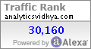](http://www.alexa.com/data/details/main?url=http://analyticsvidhya.com)

© Copyright 2015 Analytics Vidhya